 1.Describe the usage of the git stash command by using an example and also state the process by giving the screenshot of all the commands written in git bash.



It is used to save changes that you have made in your working directory without any commits and push commands

It is also used to store changes temporarily.we can switch to another branch do some work and come back to original branch and continue the changes.

Q2. By using a sample example of your choice, use the git fetch command and also use the git merge command and describe the whole process through a screenshot with all the commands and their output in git bash.

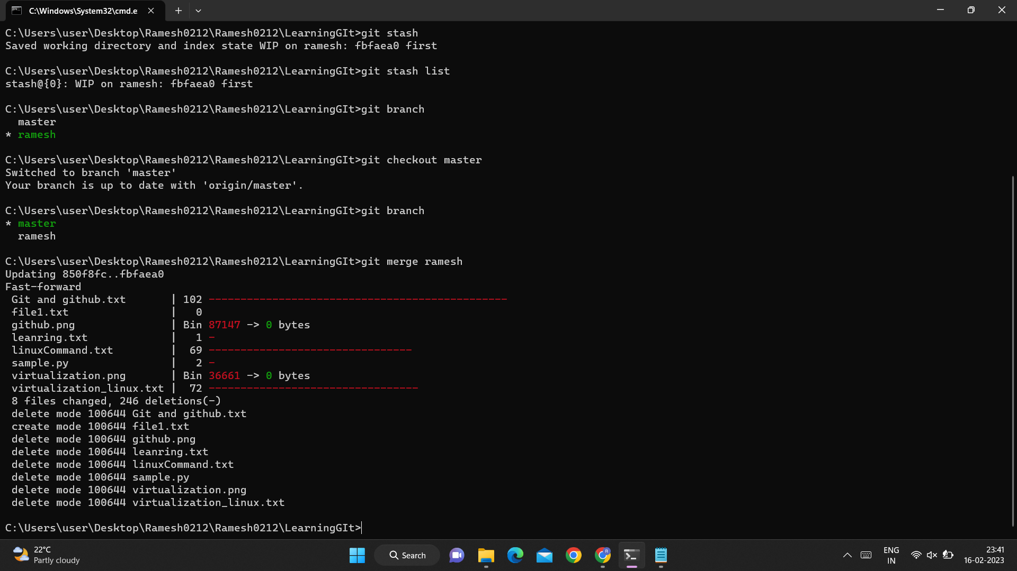

**Git merge** : git merge is used to integrate changes from one branch into the another branch.when we merge two branches.

git is combined the changes made on those branches and creats a new merge commit.

we use "git merge <branch_name>" for merging a branchAnd "git merge <master>" for merging master with a branch.

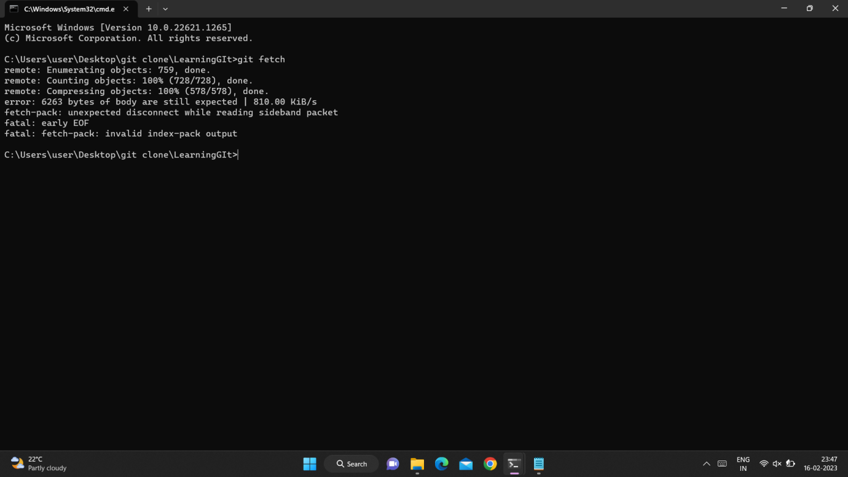

**Git fetch**:It is used to retrieves the data from a remote repository but does not merge it into the local repository. It allows you to see what changes have been made and interact with a remote repository without affecting your local repository. The "git fetch" command is used to pull the updates from remote-tracking branches. Additionally, we can get the updates that have been pushed to our remote branches to our local machines.

Q3. State the difference between git fetch and git pull by doing a practical example in your git bash and attach a screenshot of all the processes.

fetch and pull are related to obtaining updates from a remote repository.

fetch :it is used to retrieves the data from a remote repository but does not merge it into the local repository. It allows you to see what changes have been made and interact with a remote repository without affecting your local repository .



pull:it is used to retrieves the data from a remote repository and merge it into local repository

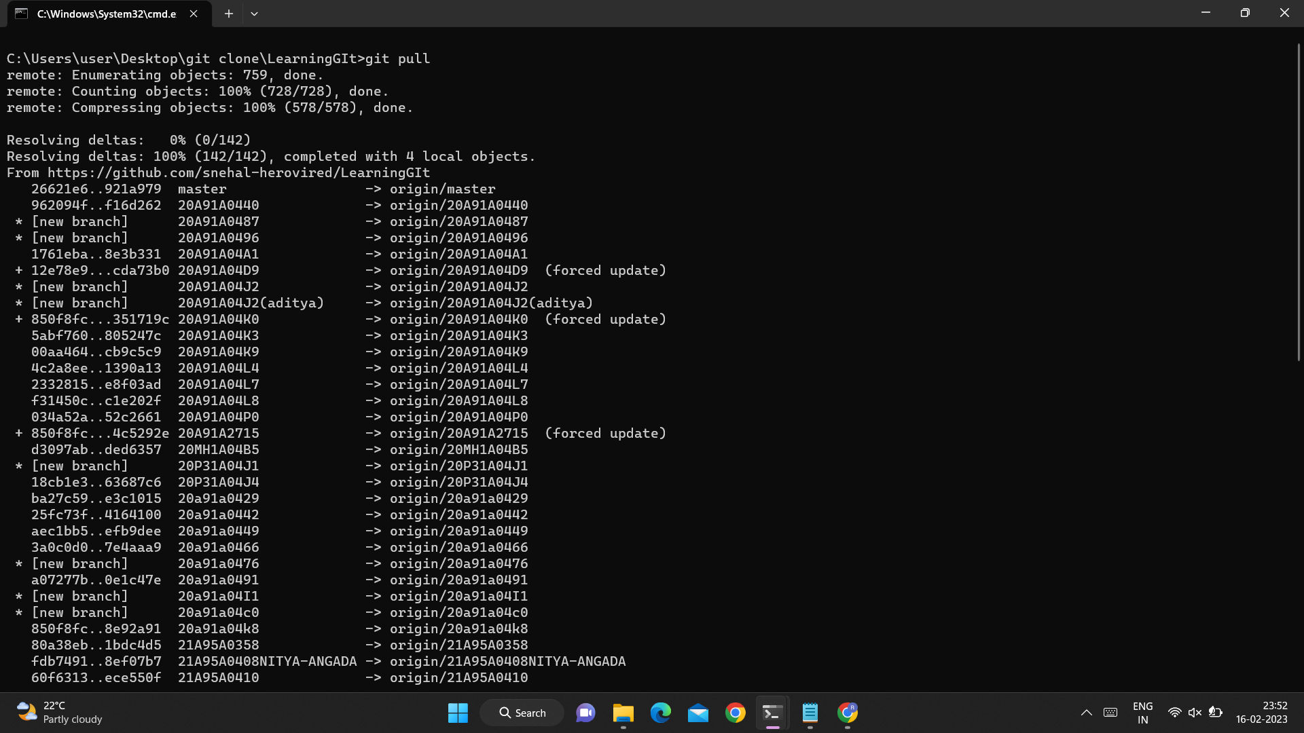

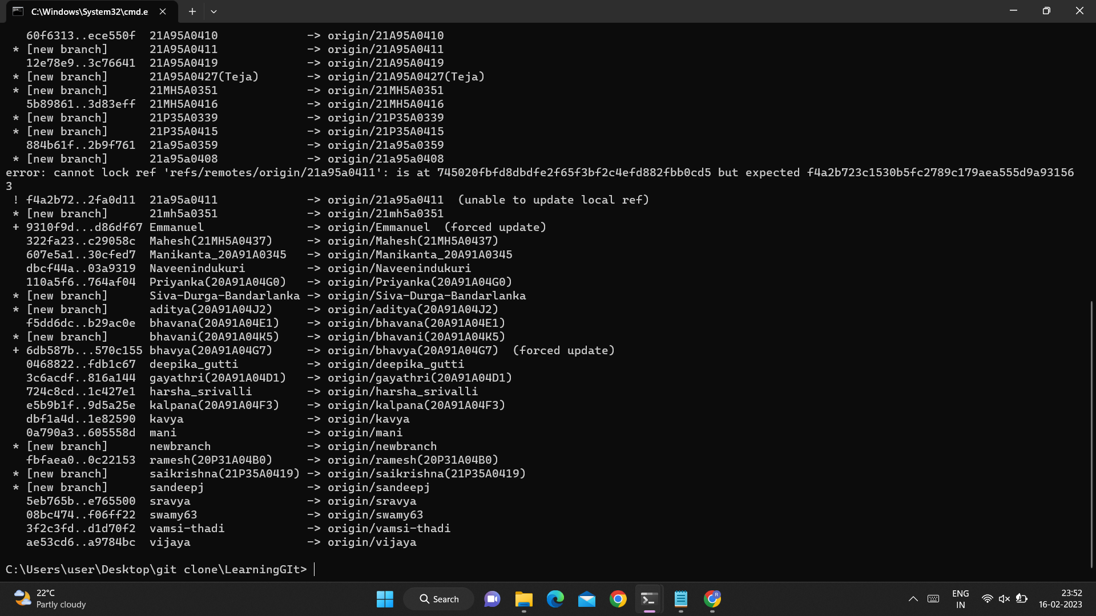

Q4. Try to find out about the awk command and use it while reading a file created by yourself. Also, make a bash script file and try to find out the prime number from the range 1 to 20.

The whole process should be carried out and by using the history command, give the screenshot of all the processes being carried out.

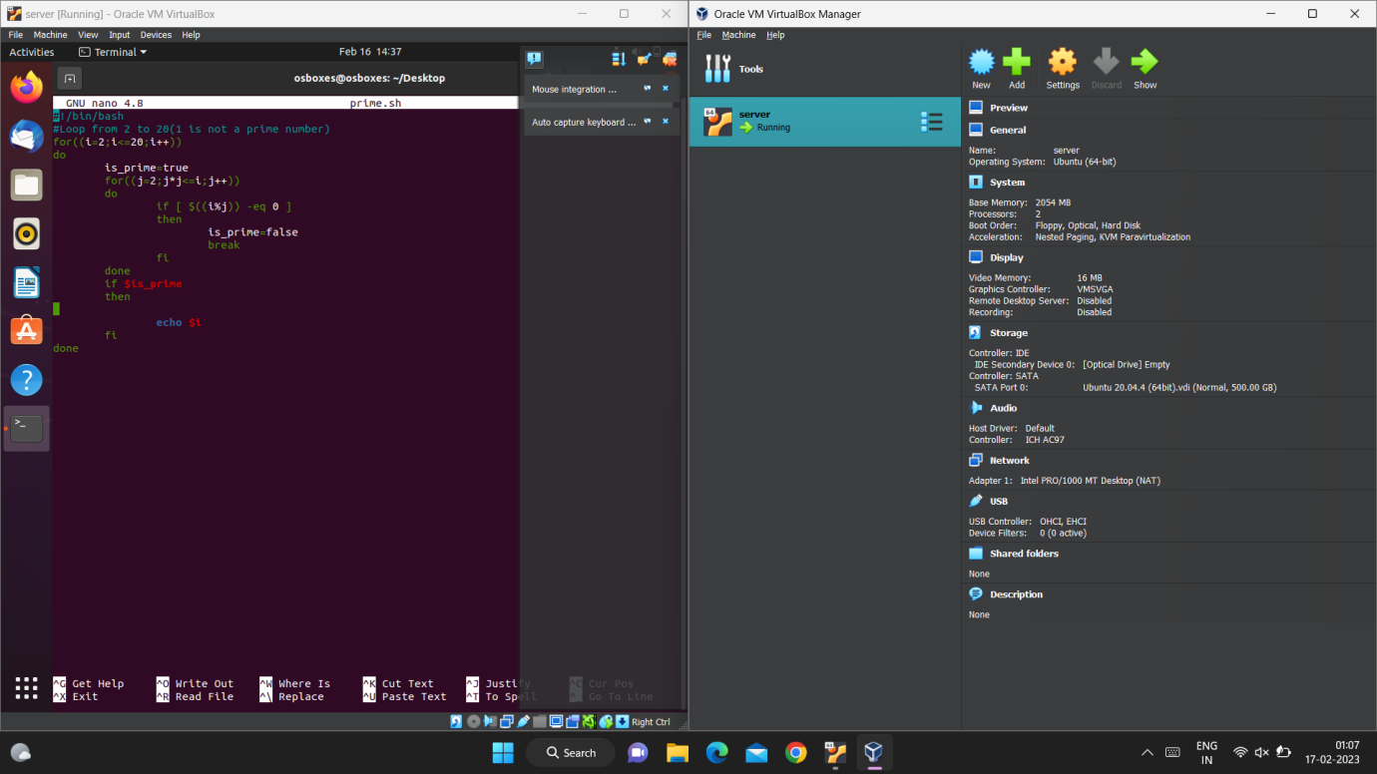

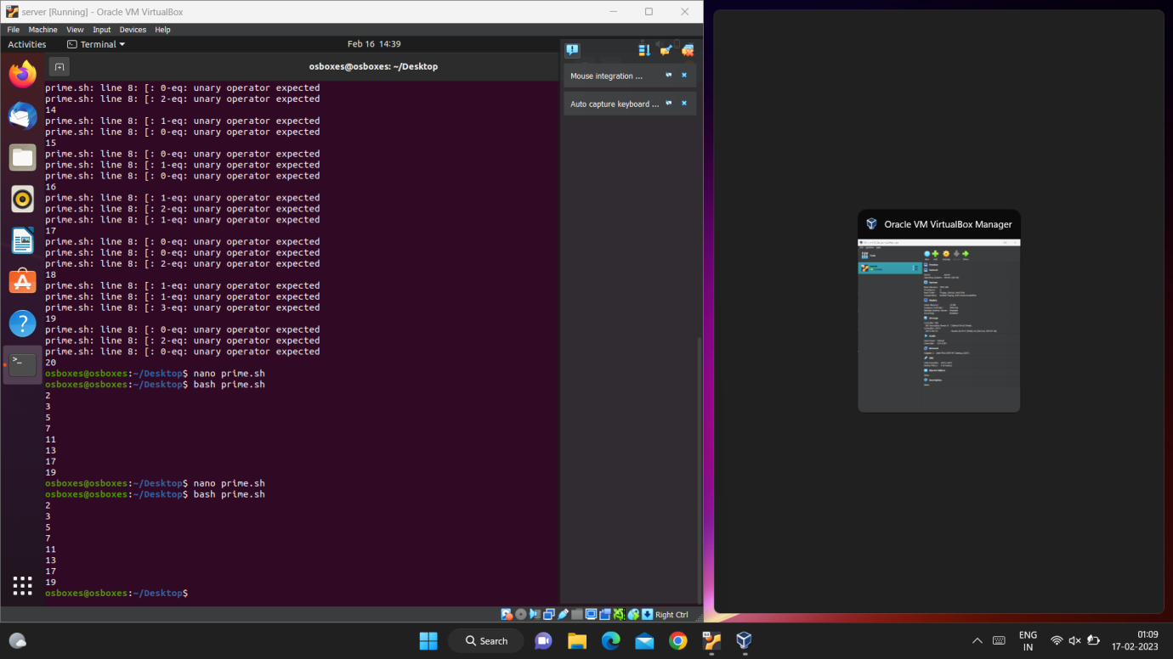

Q5. Set up a container and run a Ubuntu operating system. For this purpose, you can make use of the docker hub and run the container in interactive mode.

All the processes pertaining to this should be provided in a screenshot for grading.

The docker is used to create the containers.

PROCEDURE:

>>open the folder which is having the docker file .

>>open the git bash through the folder and it will directly open the git bash.

>>login with your docker hub login credentials.

>>now use the "docker pull image_name" to pull the ubuntu image.

>>by using the "docker run -it image_name" command run the ubuntu operating system by

creating a container using docker hub.

>> to exit from the interactive mode use "exit" command.

>>it will show that the ubuntu OS is running in the container in dockerhub.

>>after the use terminate or stop the container.

